**Unit: Manual Motor Controls Test: 7**

**Motor Nameplates and Three Phase Motors CLO#: 1**

Name ______________________________ Date ______________

**Instructions**

Select the best answer for each multiple-choice question below.

1. What article of the NEC covers motor information?
   1. 315.16
   2. 334
   3. 400
   4. 430
2. In a single-phase system, how many degrees are there between each sine wave?
   1. 90
   2. 120
   3. 180
   4. 360
3. In a split-phase system, how many degrees are there between each sine wave?
   1. 90
   2. 120
   3. 180
   4. 360
4. In a three-phase system, how many degrees are there between each sine wave?
   1. 90
   2. 120
   3. 180
   4. 360
5. List three general types of three-phase motors.
   1. Squirrel cage, shunt-wound, asynchronous motors
   2. Induction, wound rotor and synchronous motors
   3. Dual-voltage, wound rotor and shunt-wound
   4. None of the above
6. What is the purpose of the laminated iron plates within the rotor?
   1. Aid in electromagnetic induction
   2. Reduce Eddy-currents
   3. Reduce hysteresis
   4. B and C
   5. All the above
7. If a motor has an enclosure type of ODP, what does that indicate?
   1. Outdoor Protected
   2. Open Drip-proof
   3. Oxidized Dielectric Protected
   4. Open Door Plenum
8. When a motor has an enclosure type of TEFC, that indicates that it is;
   1. Totally Enclosed Fan Cooled
   2. Total Environment Face Cowling
   3. Thin Electric Face Cooled
   4. Totally Electric Fan Cooled
9. A motor has an enclosure type of TENV, what type of environment would it be used?
   1. A clean-room
   2. Submerged in a settling pond
   3. A Chemical plant with a harsh environment
   4. None of the above
10. What type of motor would you use at Laclede gas to pump natural gas?
    1. ODP
    2. EXP
    3. TEFC
    4. TENV
11. A continuous duty cycle motor can operate at its rated HP for at least;
    1. 20 minutes
    2. 3 hours
    3. 12 hours
    4. 24/7/365
12. The locked rotor code letter and the NEMA design code letter indicate the same characteristic about a motor?
    1. True
    2. False
13. Why would it be good the select a motor that has a SF > 1?
    1. Allows winding temperatures to be cooler.
    2. Protects against heat spikes
    3. Bearings will last longer
    4. A and B
    5. All the above
14. What is the effect of operating a motor above its HP but within its SF?
    1. Causes a reduction in motor RPM
    2. Will reduce Life Span
    3. Causes the motor’s efficiency to decrease
    4. A and C
    5. All the above
15. What is motor Efficiency?
    1. How fast the shaft turns verses the motors rated RPM
    2. How well the motor translates electrical power into rotational power
    3. How quickly the motor gets to full speed on startup
    4. How often the motor needs to rest
16. If a motor is not continuous duty, it is designated as?
    1. Partial duty
    2. Service duty
    3. Intermittent duty
    4. B and C
    5. All the above
17. When a motor is rated for inverter duty, what does that indicate?
    1. It can be used on a solar system
    2. It can be used with a variable frequency drive.
    3. It is a DC motor that will accept an AC input source
    4. It is reversible
18. A motors *Power Factor (PF)* is useful to determine
    1. The motors efficiency
    2. The motors power requirements
    3. The overall quality of the motor
    4. All of the above
19. In the diagram below show how you would connect the motor to its higher voltage. Show jumper connections and L1, L2, L3 input lines.



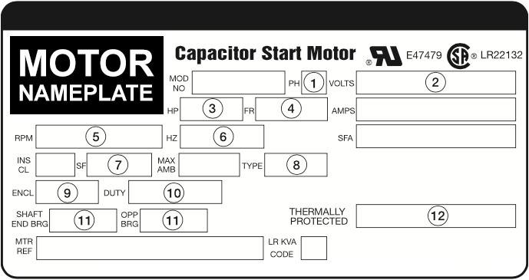

1. TEFC _______
2. How long the motor can run _______
3. Three-Phase Motor _______
4. Shaft Speed _______
5. Applied Power _______
6. 145˚C _______
7. Service Frequency _______
8. Motor’s Construction _______
9. Output Power _______
10. Draw a schematic for a 480V three-phase motor that is controlled by a motor starter. (three-phase portion only)
11. Construct the truth table, formula and state the type of logic for the control schematic below.



1. Construct the truth table, formula and state the type of logic for the control schematic below.



1. Construct the truth table and formula for the control schematic below.

